Matthew Hoffman

CPE 403 – Advanced Embedded Systems

CC1350 Lab 1

# Task 1: Replacing the contents of hello.c

Import of hello.c example

# Task 2: Debugging Tools

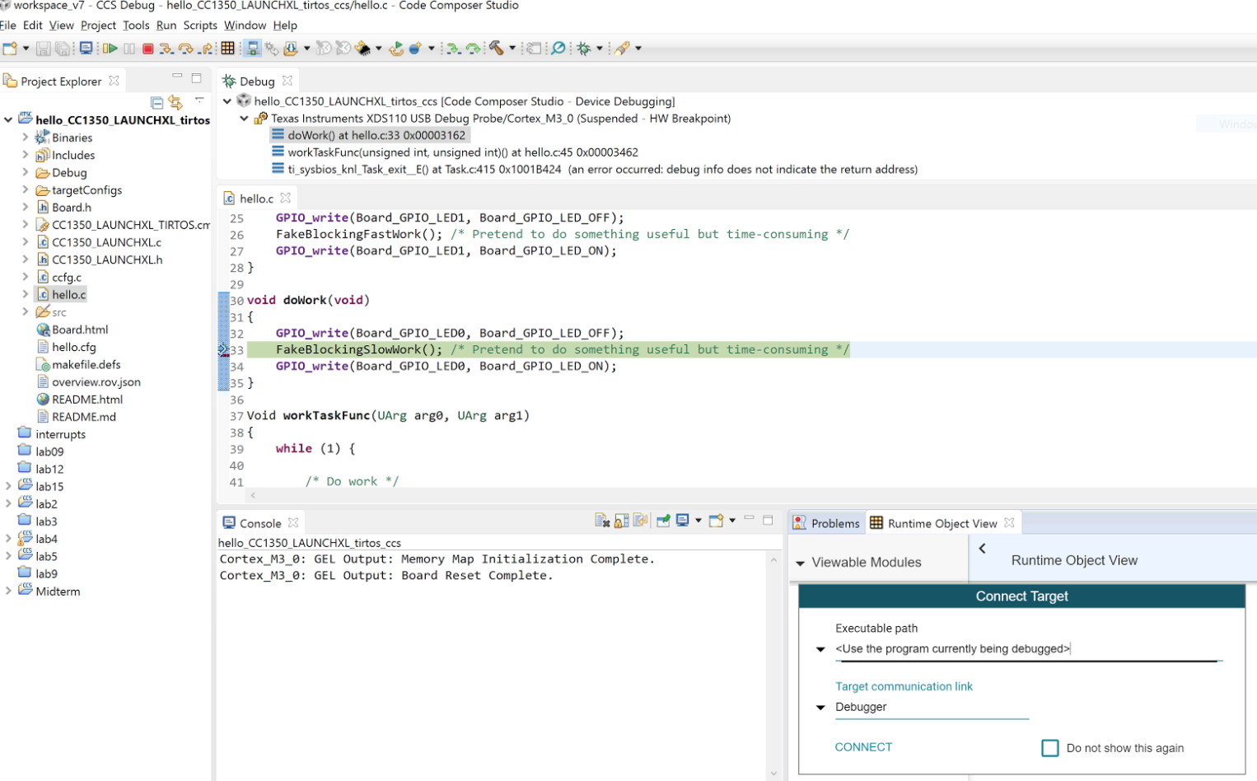

**Figure 1 – Task 2.a Connect Runtime Object View**

**Figure 2 – Task 2.b Stack Usage**

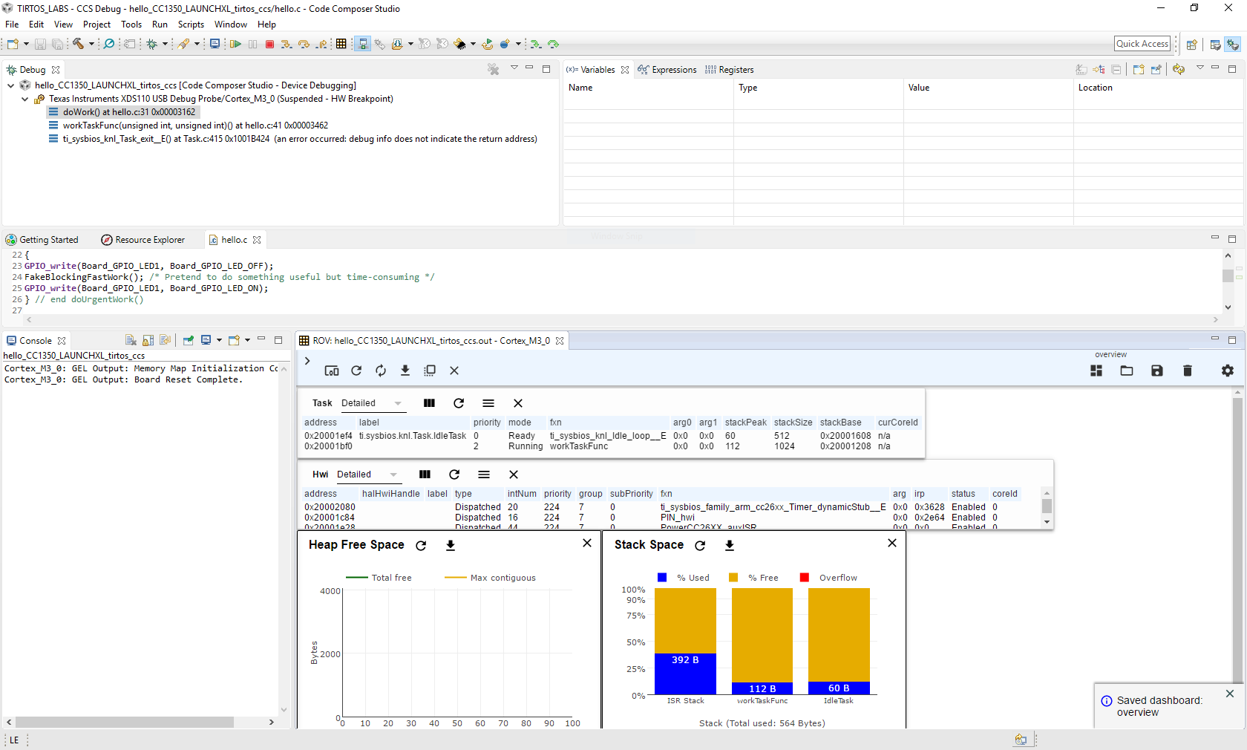

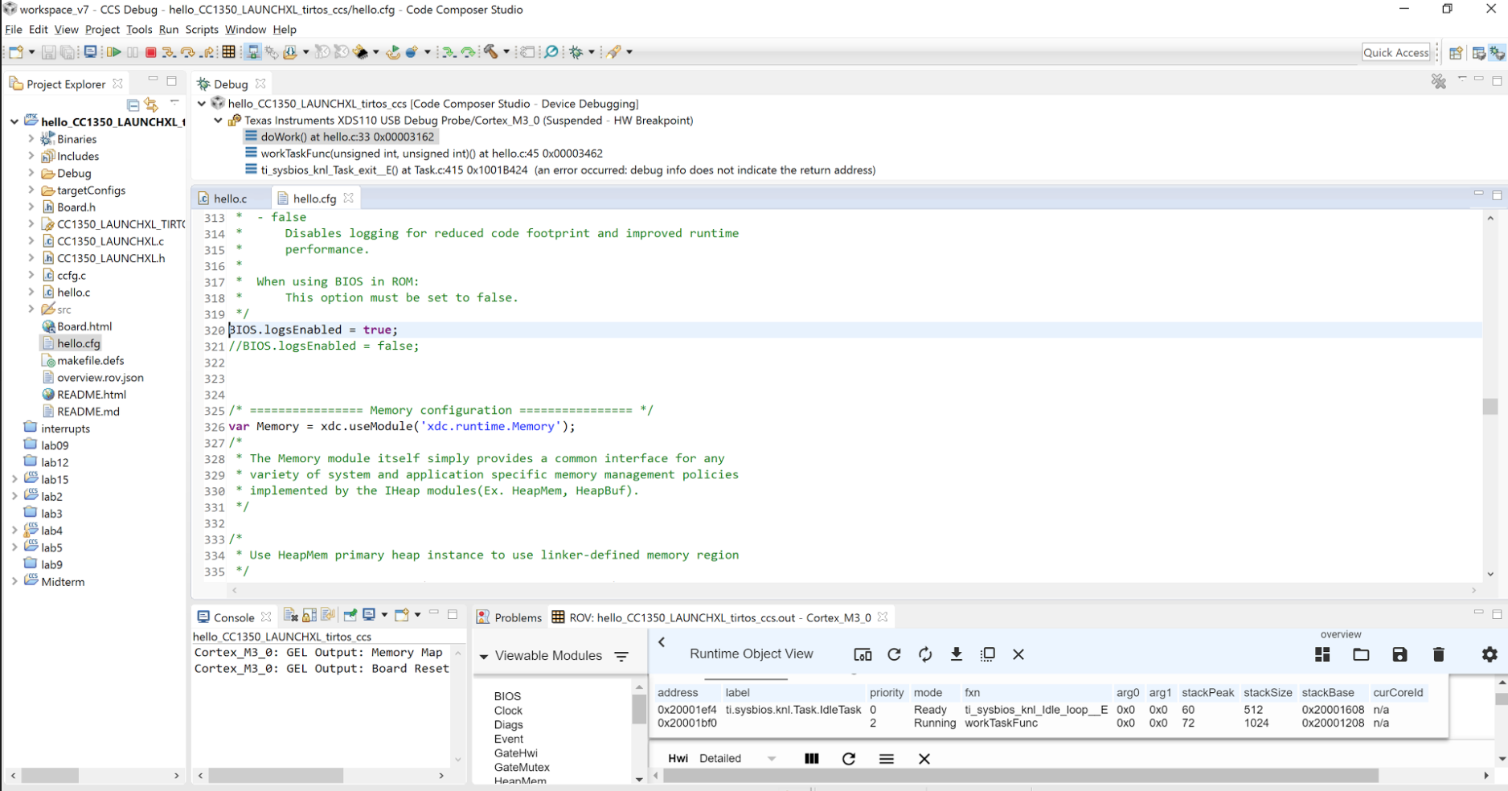**Figure 3 – Task 2.c Replacing the config file**

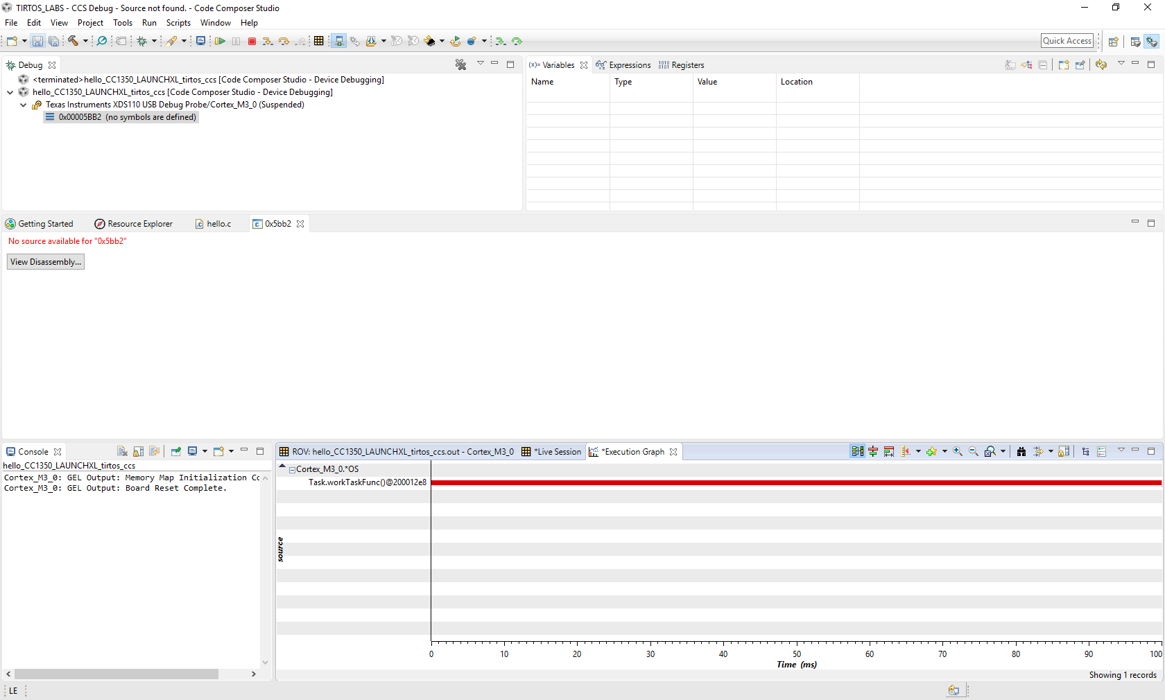

**Figure 4 – Task 2.d Execution Analysis Single Task**

# Task 3: Sleeping Well

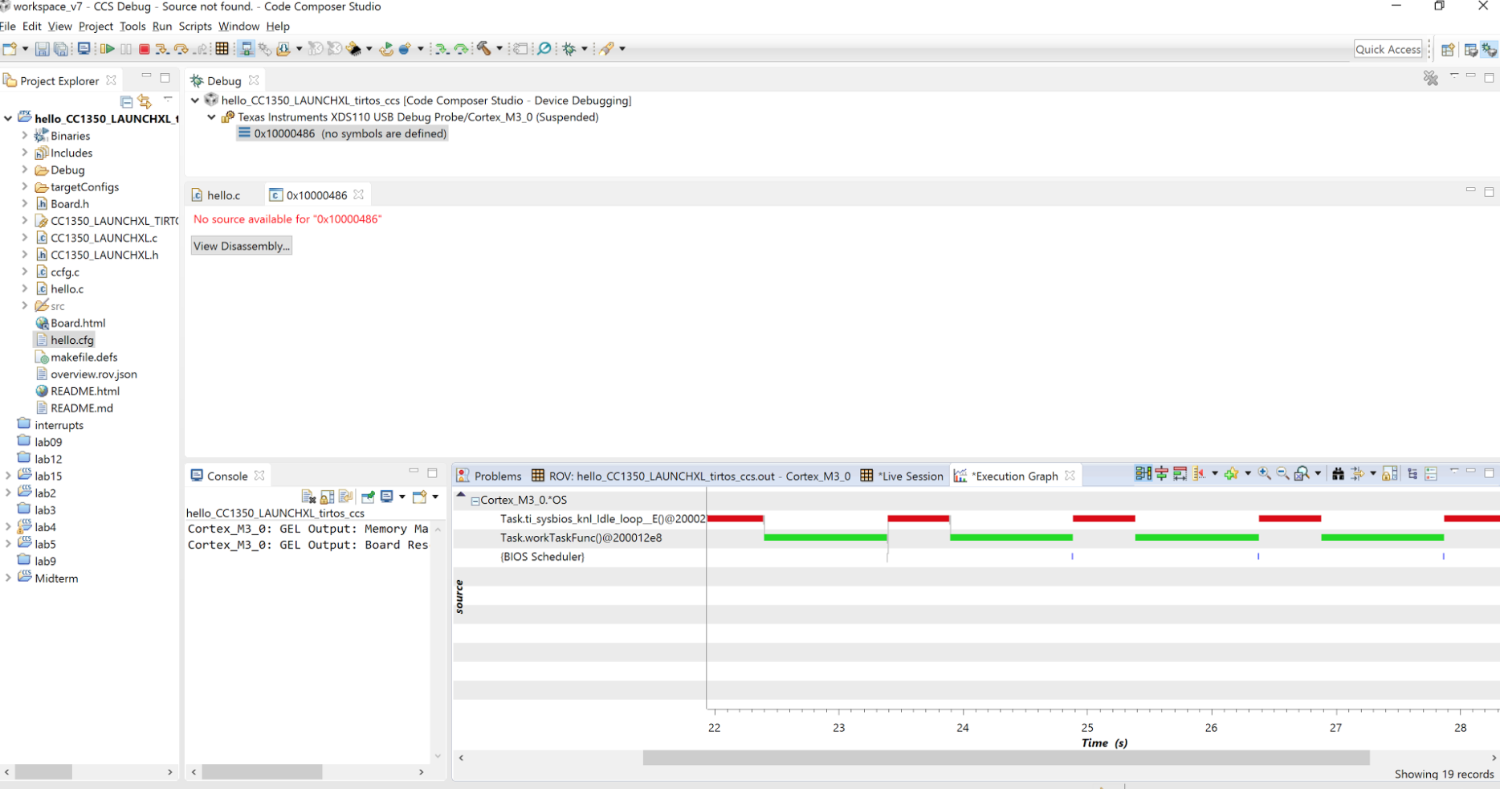

**Figure 5 – Task 3.a Execution Graph Changes**

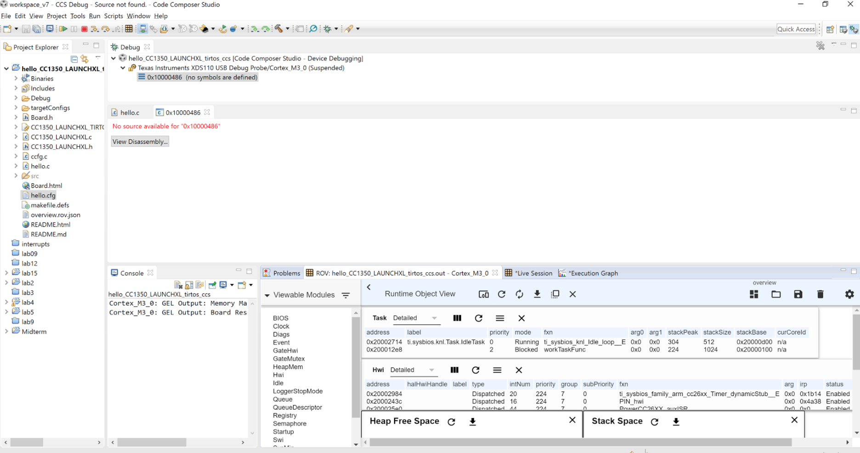

**Figure 6 – Task 3.b Task Details**

# Task 4: Executing Urgent Work

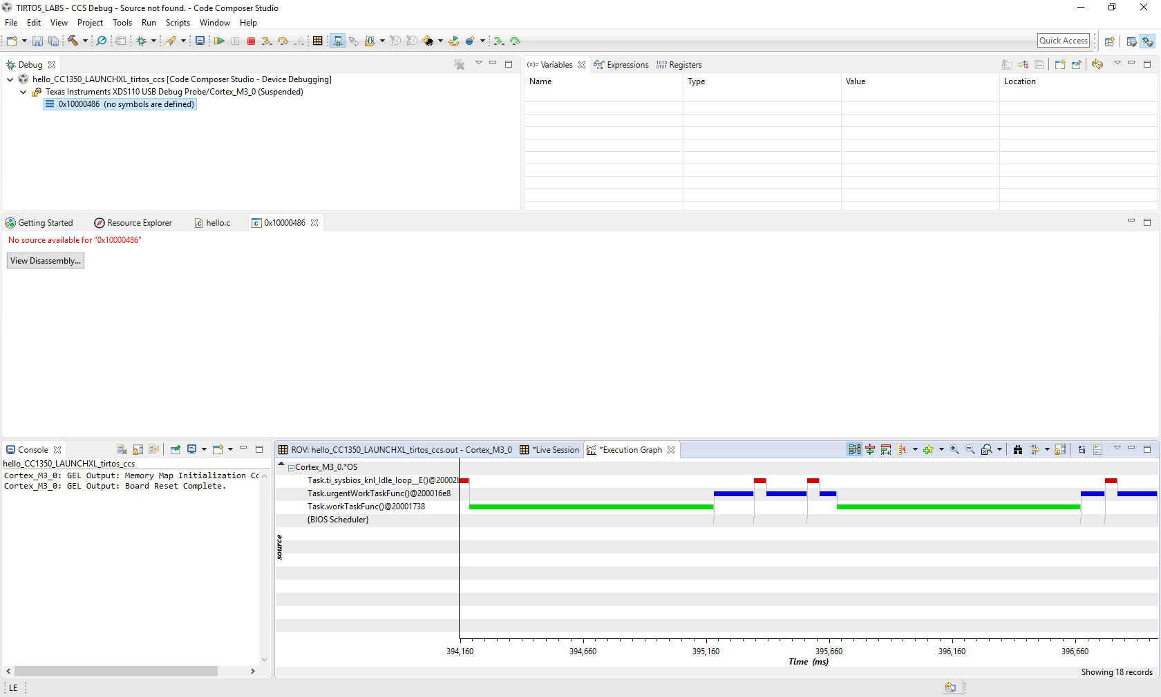

**Figure 7 – Task 4 Execution Graph**

# Task 5: Changing Priority

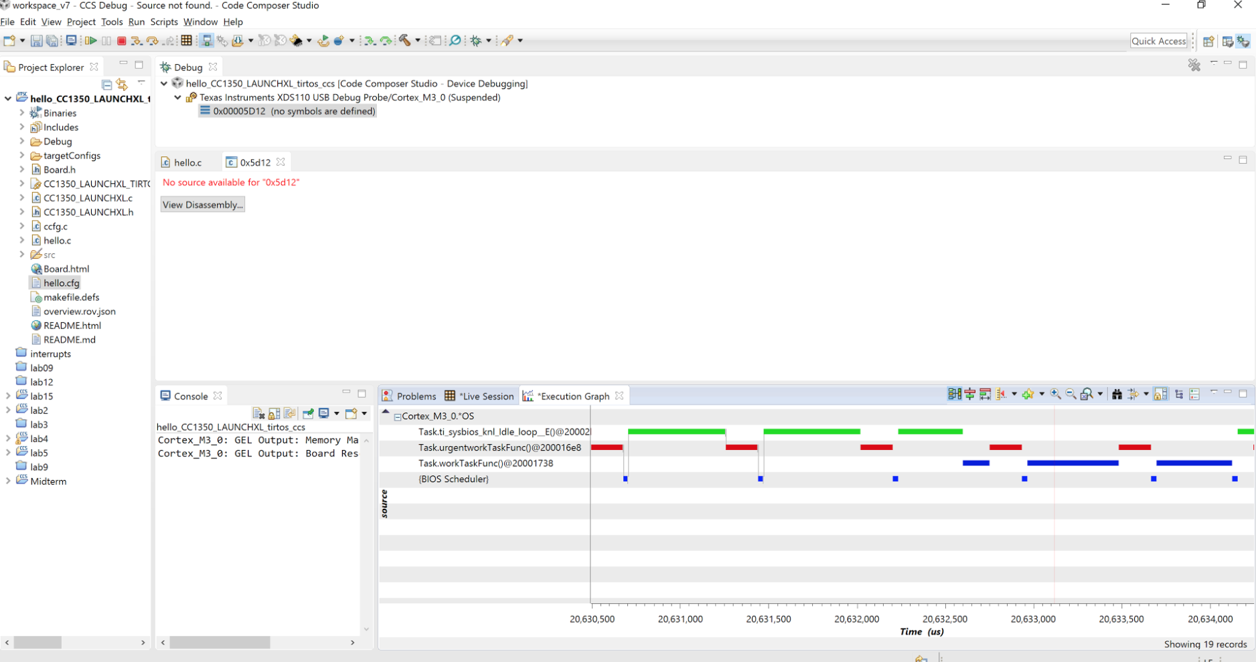

**Figure 8 – Task 5 Priority Change**